API Security Risk Assessment Report
Prepared For: Future Interns - Cybersecurity Task 3
Assessor: Cathrine Mpebe
Date: April 29, 2026
Classification: Public / Read-Only Assessment

1. Executive Summary
A read-only API security assessment was conducted against the JSONPlaceholder API (https://jsonplaceholder.typicode.com). The assessment followed the OWASP API Security Top 10 framework and used Postman for API testing
Key Findings:
- Critical Risk (1): No authentication required for any endpoint
- High Risks (2): Broken Object Level Authorization, Excessive data exposure
- Medium Risks (2): Missing rate limiting, No input validation
- Low Risk (1): Information disclosure via headers

2. Scope & Methodology
Item | Details
Target API | JSONPlaceholder
Endpoints Tested | /posts, /users, /comments, /todos
Testing Date | April 29, 2026
Assessment Type | Read-only, non-intrusive
Tools Used | Postman v11, Browser DevTools
Framework | OWASP API Security Top 10 2023

Testing Methodology:
- Authentication assessment - attempted access without credentials
- Authorization testing - BOLA/IDOR checks via ID manipulation
- Data exposure analysis - review of response fields
- Input validation - boundary and special character testing
- Rate limiting - rapid request sequence testing
- Information disclosure - header and error message inspection

3. Risk Summary
ID | Finding | Severity | Business Impact
API-01 | No Authentication | CRITICAL | Complete data exposure; anyone can access all API resources
API-02 | Broken Object Level Authorization | HIGH | Users can access other users' private data by changing ID values
API-03 | Excessive Data Exposure | HIGH | API returns sensitive fields (address, geo, email) unnecessarily
API-04 | Missing Rate Limiting | MEDIUM | Vulnerable to DoS attacks and brute force enumeration
API-05 | No Input Validation | MEDIUM | Potential for injection attacks if connected to real database
API-06 | Information Disclosure | LOW | Leaks server technology stack to potential attackers

4. Detailed Findings

Finding API-01: No Authentication Required (CRITICAL)
Description:

The API accepts all requests without requiring any API key, JWT token, OAuth, or other authentication mechanism. Both GET and POST operations are accessible to anonymous users.
Evidence:
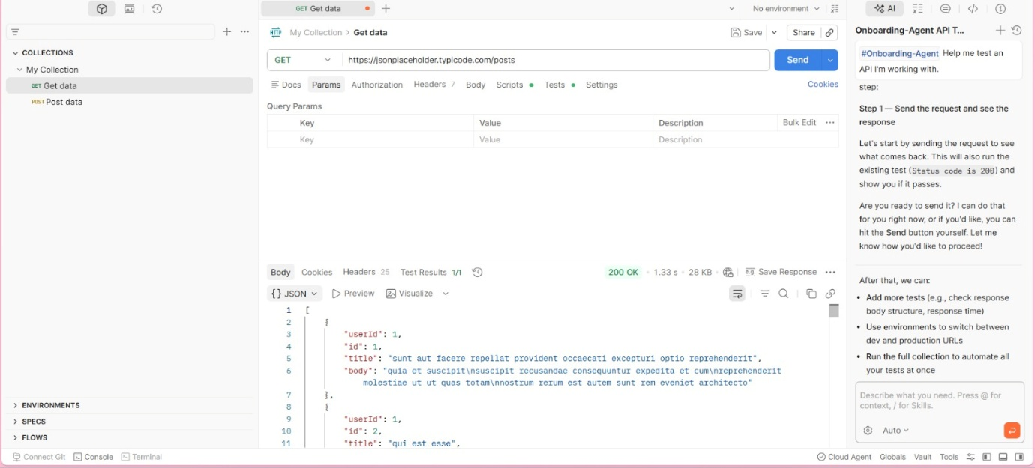

Attack Scenario:
An attacker could enumerate all user IDs (/users/1, /users/2, through /users/100) and harvest complete user profiles including names, emails, addresses, and GPS coordinates without ever identifying themselves.
Remediation:
- Immediate: Implement API key authentication for all endpoints
- Long-term: Deploy OAuth2 with scoped permissions (read vs write)
- Code example (Node.js):
app.use('/api', authenticate({
verify: (req, res, buf) => { req.rawBody = buf; }
}));

Finding API-02: Broken Object Level Authorization (HIGH)
Description:
The API does not validate whether the requesting user is authorized to access a specific resource. Any user can access any resource by modifying the ID parameter.
Evidence:
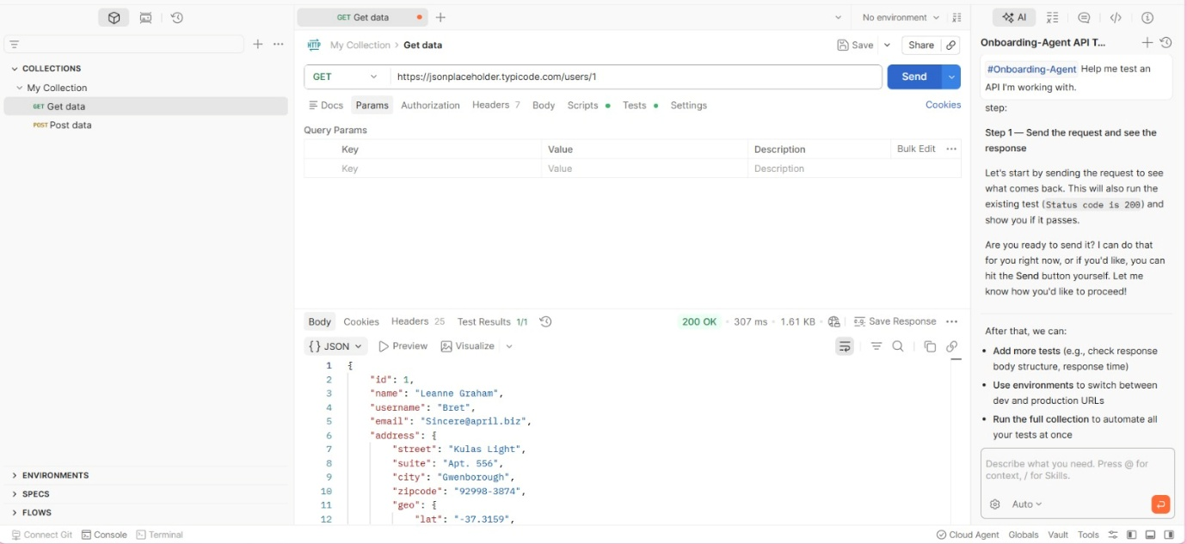

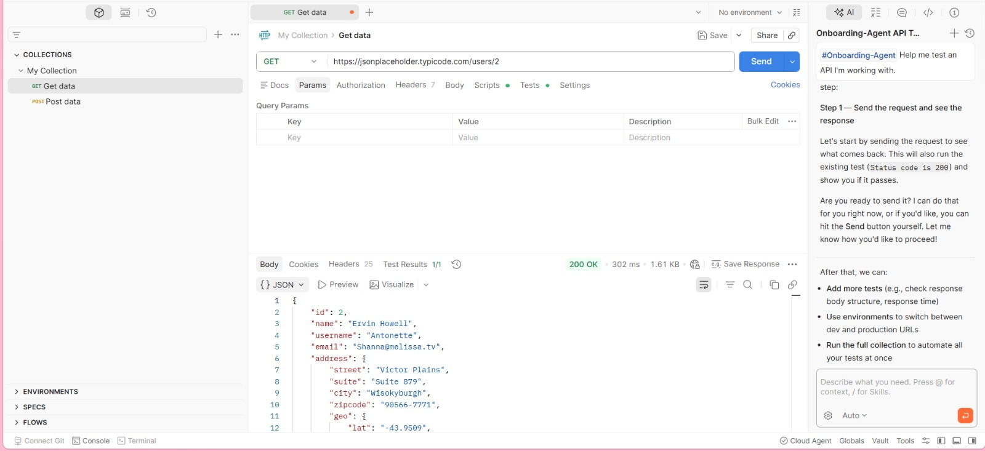

Attack Scenario:
In a real e-commerce API, a customer could change GET /orders/123 to GET /orders/124 and view another customer's order details including names, addresses, and payment information.
Remediation:
- Implement server-side authorization checks for every request
- Never trust client-side ID parameters without verification
- Use UUIDs instead of sequential integers for resource IDs
- Code example:
if (request.user.id !== resource.userId && !request.user.isAdmin) {
return 403 Forbidden;
}

Finding API-03: Excessive Data Exposure (HIGH)
Description:
The API returns more data fields than necessary for typical use cases. For example, /users/1 returns address, GPS coordinates, phone, email, and company details even when only a username may be needed.
Evidence:
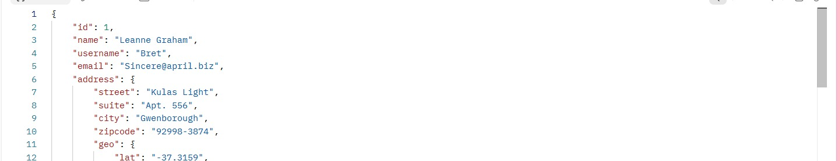
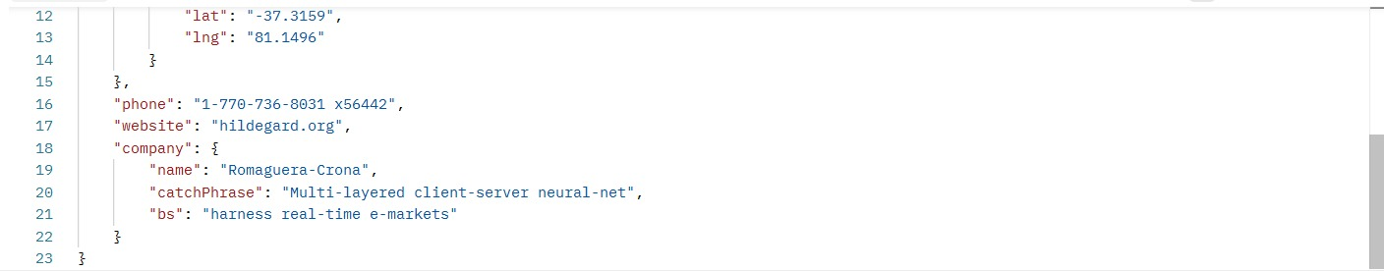

Attack Scenario:
A mobile app displaying usernames should not also receive customer email addresses, phone numbers, and home addresses. This violates the principle of least privilege and GDPR data minimization requirements.
Remediation:
- Implement GraphQL or JSON:API with sparse fieldsets
- Create role-specific response DTOs (Data Transfer Objects)
- Example fix:
// Instead of returning entire user object
return { id: user.id, name: user.name, avatar: user.avatar };

Finding API-04: Missing Rate Limiting (MEDIUM)
Description:
The API does not implement any rate limiting. Multiple rapid requests (50+ in 5 seconds) all returned 200 OK responses with no 429 (Too Many Requests) status codes.
Evidence:

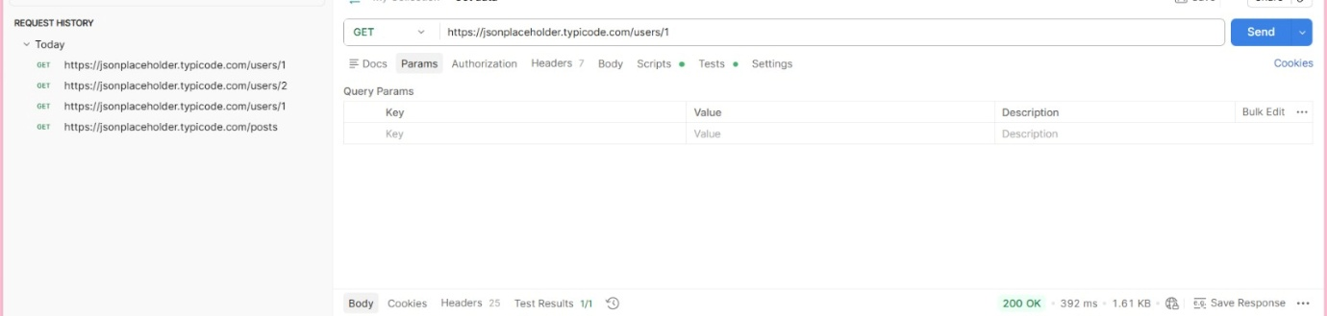

Attack Scenario:
An attacker could:
- Scrape all 10,000 posts in under 30 seconds
- Launch a denial-of-service attack with minimal resources
- Brute force user ID numbers to discover valid accounts
Remediation:
- Implement rate limiting using Redis or similar
- Typical limits: 100 requests per minute for authenticated users, 20 for anonymous
- Example (Express.js):
const rateLimit = require('express-rate-limit');
const limiter = rateLimit({ windowMs: 60*1000, max: 100 });
app.use('/api', limiter);

Finding API-05: No Input Validation (MEDIUM)

The API accepts malformed input, extremely long strings (10,000+ characters), and special characters including SQL injection and XSS payloads without validation or sanitization.
Evidence:
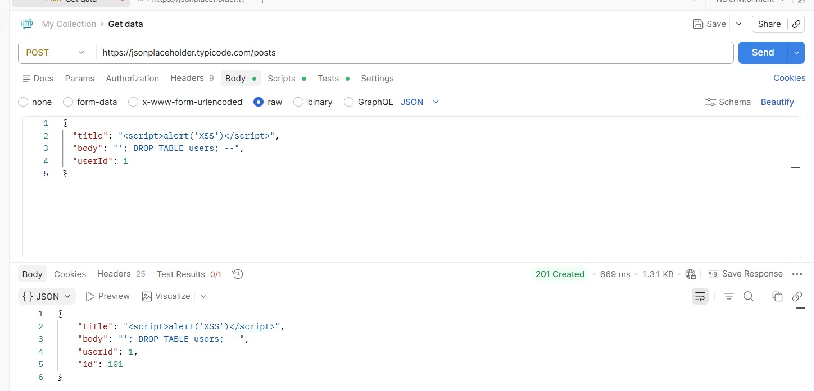

Attack Scenario:
While JSONPlaceholder is a mock API, in production this would allow:
- Stored XSS attacks (malicious scripts saved to database)
- SQL injection if requests hit a real database
- Buffer overflow attempts

Remediation:
- Validate all input against strict schemas (use JSON Schema or Zod)
- Sanitize output based on context
- Example validation:
const schema = Joi.object({
title: Joi.string().max(100).required(),
body: Joi.string().max(2000).required()
});

Finding API-06: Information Disclosure (LOW)
Description:
The API response headers and error messages expose technical information about the underlying infrastructure
Headers observed in responses:
X-Powered-By: Express
Server: Cowboy (reveals Erlang/OTP stack)
Attack Scenario:
Attackers can tailor exploits based on known vulnerabilities for specific server versions (e.g., Express-specific attacks, Cowboy-specific CVEs).
Remediation:
- Remove or mask identifying headers
- Use generic error messages (don't reveal if error is from database vs validation)
- Configuration example (Express):
app.disable('x-powered-by');
app.use(helmet()); // Sets secure headers

5. Remediation Roadmap
Priority | Finding | Effort | Estimated Timeline
P0 | No Authentication | Medium | 1-2 weeks
P1 | Broken Object Level Authorization | Medium | 2-3 weeks
P1 | Excessive Data Exposure | Low | 1 week
P2 | Missing Rate Limiting | Low | 3-5 days
P2 | No Input Validation | Medium | 2-3 weeks
P3 | Information Disclosure | Low | 1 day

Appendix: Test Cases Executed
# | Method | Endpoint | Request | Response Status | Finding
1 | GET | /posts | No headers | 200 OK | No authentication
2 | GET | /users/1 | No auth | 200 OK | BOLA possible
3 | GET | /users/2 | No auth | 200 OK | BOLA confirmed
4 | GET | /users/1 | - | 200 OK | Excessive data (17 fields)
5 | POST | /posts | XSS payload | 201 Created | No validation
6 | POST | /posts | 50,000 char string | 201 Created | No length limits
7 | GET x30 | /posts | Rapid sequential | All 200 OK | No rate limiting
8 | GET | /invalid | - | 404 Not Found | Info disclosure in headers
9 | POST | /posts | Extra fields (isAdmin) | 201 Created | Mass assignment possible

7. Conclusion
The JSONPlaceholder API contains multiple security gaps that would pose serious risks in a production environment. The most critical issues are the complete lack of authentication and broken authorization controls, which would allow any internet user to access or modify any data.
For a production API, the following MUST be implemented before launch:
- Authentication (OAuth2, JWT, or API keys)
- Authorization checks on every endpoint
- Rate limiting
- Input validation
Business Impact if Deferred: Data breach, regulatory fines (GDPR/CCPA), reputational damage, service downtime.

